Q1:
Convert body's units from kg to g .I think bigger animals should have bigger brain to control their bodies. Body weights influence and decide the sizes of brains. So using brain weight as response and body weight as predictor is better.

From scatter plot, people read it difficultly. After converting original data to natural logrithm data,that is more readable.

Before converting:

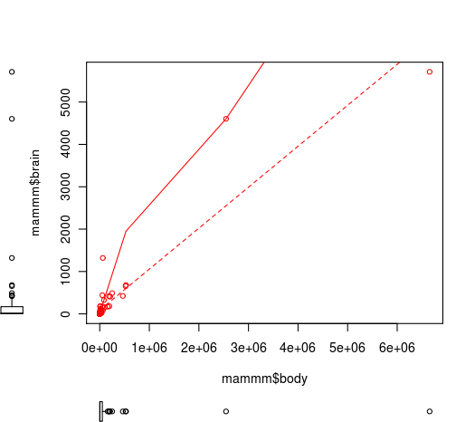

After converting:
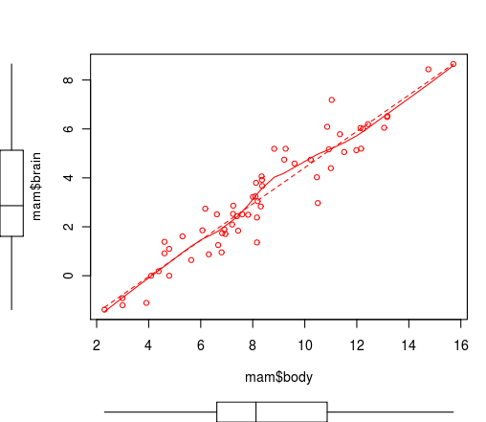

Q2:
Fitted regression line:
total number:60
slope:0.74
y-intercept:-3
regression equation: brain = -2.998 + 0.7415*body

the standard error of coefficients:
brain: 0.2793
body: 0.05173

s:0.73968

R^2: 90.40%

Q3:
By graphic, we can see it shows linearity;
The distribution is normal, the points on plot fall close to diagonal line on normal probability plot of residuals;
By plots of residuals versus predicted value,residuals are getting bigger as a function of predicted value;
By an autocorrelation plot of residuals,most of residual autocorrelations fall within 95% confidence intervals around zero.

Q4:

variable 95%CI
brain (13.30313,44.70118)
body (1944.96643,9209.58436)

Q5:
Let μd = mean of the difference values for two sets of brain weights data,
Hypotheses conclusion
Ho: μd = 0 no difference for two sets of data
Ηα:μd ≠ 0 differences exist in brain weights between two sets of data.

Test of mu = 0 vs not = 0

Variable N Mean StDev SEMean 95% CI T P
diff 50 1.821 1.054 0.149 (1.522, 2.120) 12.22 0.000
Because of P-value=0.000 which is less than 0.05 even less than 0.01, Ho is not true and Ha is correct.So that specialist is not true.
Q6:
fitted regression line of primates:
total numbers: 10
slope:0.87
y-intercept:-3.24
regression equation: brain = -3.24 + 0.8722*body

fitted regression line of non-primates:
total numbers: 49
slope:0.72
y-intercept:-3.04
regression equation: brain = -3.035 + 0.7245*body

The slope of fitted regression line of primates is higher than fitted regression line of non-primates',it means primates animals have bigger brain weights than non-primates with same body weights and heavier body weights both animals have, more obversely to see primate animals have bigger brain weights than non-primates'.

Q7:
The estimate is 1.079147118
95% prediction interval:

